**Microprocessor and Computer Architecture Laboratory**

**UE19CS256**

**4th Semester, Academic Year 2020-21**

Date: 15/2/21

|  |  |  |
| --- | --- | --- |
| Name: Adithya M S | SRN: PES1UG19CS027 | Section: A |

Week#____4_______ Program Number: ___1___

**Write an ALP to add corresponding elements of an array.**

**Ex: for(i=0;i<n;i++)**

**C[i]=a[i]+b[i]**

**Code:**

.data

a:.word 10,20,30,40,50

b:.word 10,20,30,40,50

c:.word 0,0,0,0,0

.text

ldr r0,=a

ldr r1,=b

ldr r2,=c

mov r3,#5

loop:

ldr r4,[r0],#4

ldr r5,[r1],#4

add r6,r4,r5

str r6,[r2],#4

sub r3,r3,#1

cmp r3,#0

bne loop

swi 0x11

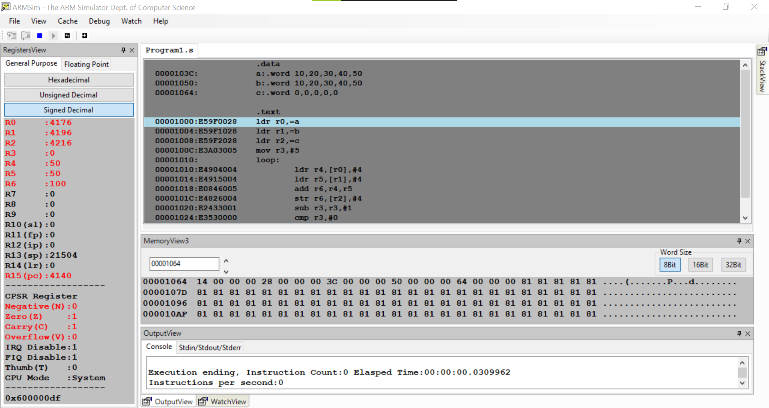

Week#____4_______ Program Number: ___2___

**Write an ALP to find the product of corresponding elements of an array.**

**Ex: for(i=0;i<n;i++)**

**C[i]=a[i]*b[i]**

**Code:**

.data

a:.word 10,20,30,40,50

b:.word 10,20,30,40,50

c:.word 0,0,0,0,0

.text

ldr r0,=a

ldr r1,=b

ldr r2,=c

mov r3,#5

loop:

ldr r4,[r0],#4

ldr r5,[r1],#4

mul r6,r4,r5

str r6,[r2],#4

sub r3,r3,#1

cmp r3,#0

bne loop

swi 0x11

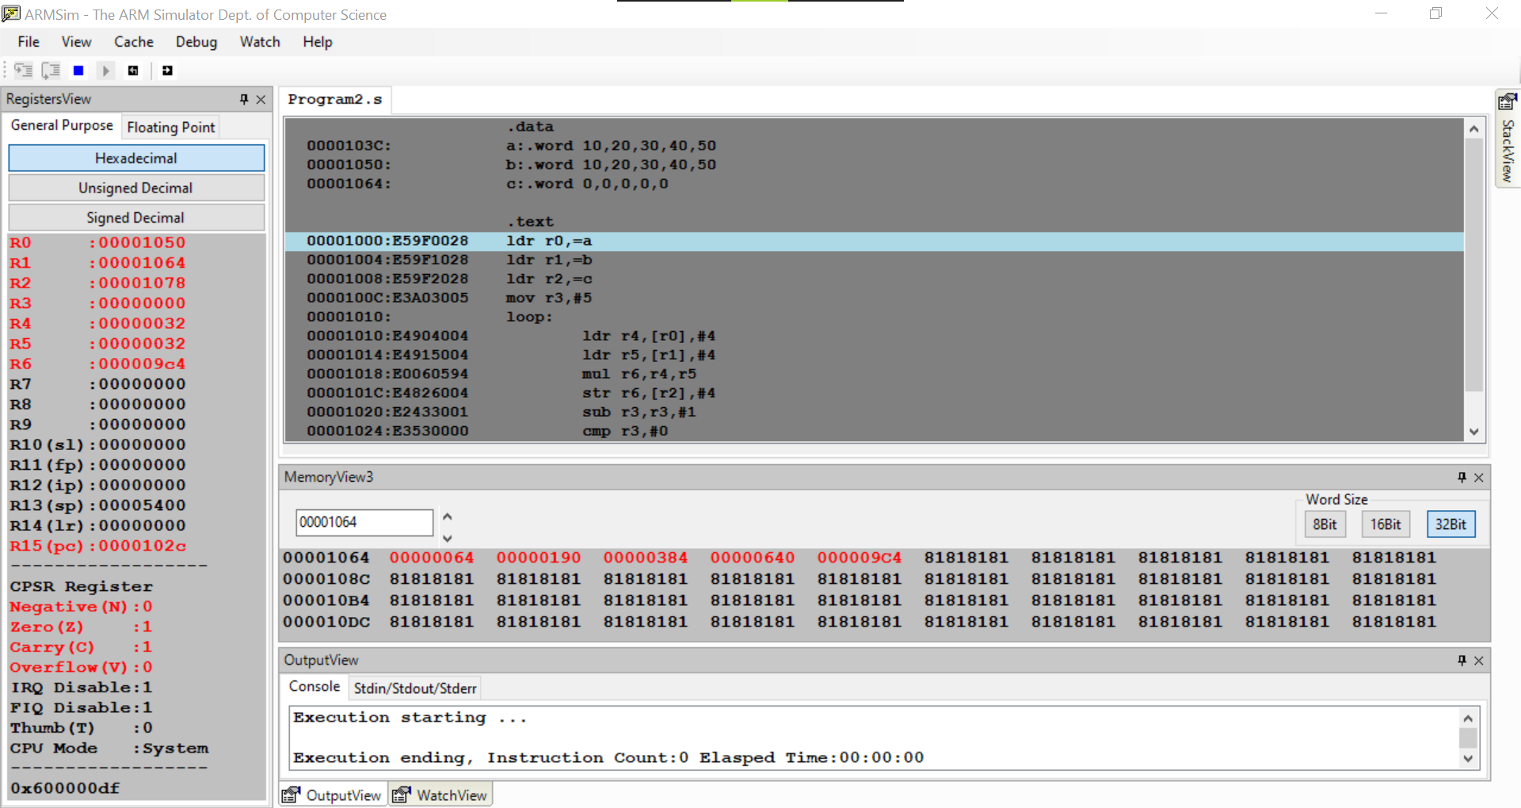

Week#____4_______ Program Number: ___3a___

**Write an ALP to perform Convolution operation using MUL instruction (Addition of multiplication of respective numbers of loc A and loc B)**

**Code:**

.data

a:.word 10,20,30,40,50

b:.word 10,20,30,40,50

c:.word 0,0,0,0,0

.text

ldr r0,=a

ldr r1,=b

ldr r2,=c

mov r3,#5

mov r7,#0

loop:

ldr r4,[r0],#4

ldr r5,[r1],#4

mul r6,r4,r5

add r7,r7,r6

str r7,[r2],#4

sub r3,r3,#1

cmp r3,#0

bne loop

swi 0x11

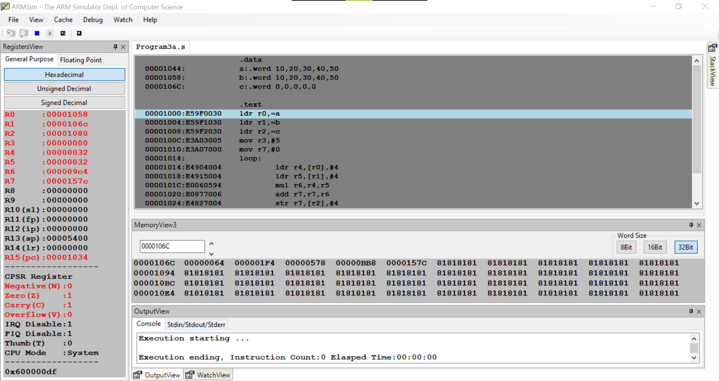

Week#____4_______ Program Number: ___3b___

**Write an ALP to perform Convolution using MLA instruction (Addition of multiplication of respective numbers of loc A and loc B).**

**Ex: for(i=0;i<n;i++)**

**C[i]=C[i]+a[i]*b[i]**

**Code:**

.data

a:.word 10,20,30,40,50

b:.word 10,20,30,40,50

c:.word 0,0,0,0,0

.text

ldr r0,=a

ldr r1,=b

ldr r2,=c

mov r3,#5

mov r6,#0

loop:

ldr r4,[r0],#4

ldr r5,[r1],#4

mla r6,r4,r5,r6

str r6,[r2],#4

sub r3,r3,#1

cmp r3,#0

bne loop

swi 0x11

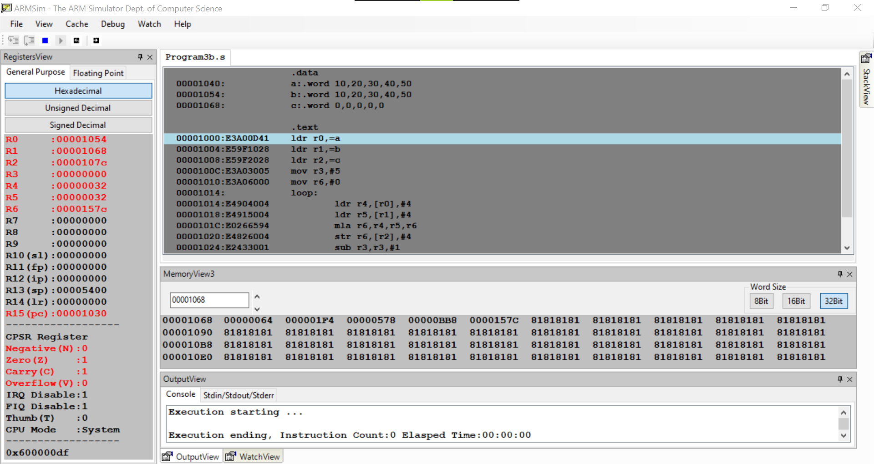

Week#____4_______ Program Number: ___4___

**Consider an 2D array. Write an ALP using ARM7TDMI-ISA, to retrieve / access any element from the array.**

**Code:**

.data

a:.word 10,20,30,40,50,60,70,80,90

b:.word 0,0,0

.text

ldr r0,=a

mov r1,#1 ;Row number

mov r2,#3 ; Number of elements in a row

mov r3,#1 ; Column number

mov r4,#4

mla r5,r1,r2,r3 ; Accessing 5th element

mul r5,r4,r5

ldr r6,=b

ldr r7,[r0,r5]

str r7,[r6],#4

mov r1,#2

mov r3,#1

mla r5,r1,r2,r3 ; Accessing 8th element

mul r5,r4,r5

ldr r7,[r0,r5]

str r7,[r6],#4

mov r1,#0

mov r3,#0

mla r5,r1,r2,r3 ; Accessing 1st element

mul r5,r4,r5

ldr r7,[r0,r5]

str r7,[r6],#4

swi 0x11

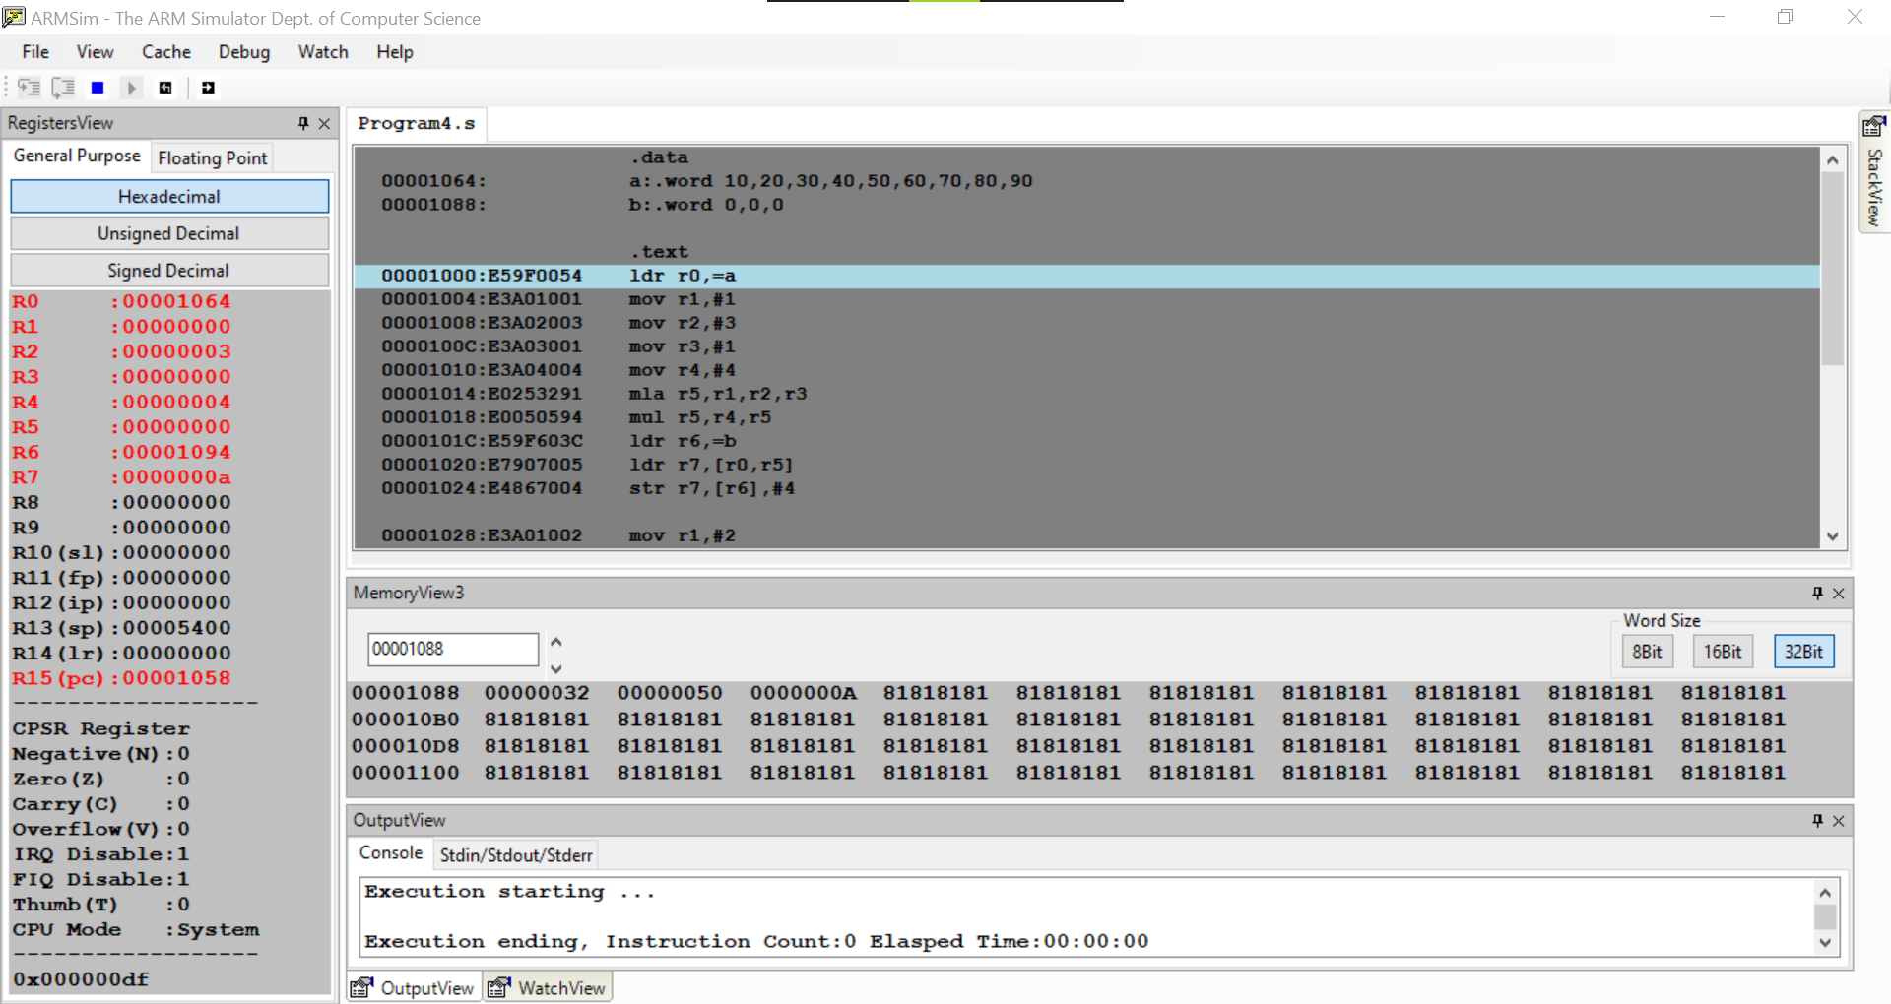

Week#____4_______ Program Number: ___5___

**Write an ALP to add corresponding elements of an 2D - array.**

**Ex: for(i=0;i<n;i++)**

**for(j=0;j<n;j++)**

**c[i][j]=a[i][j]+b[i][j]**

**Code:**

.data

a:.byte 1,2,3,4,2,3,1,2,1

b:.byte 1,1,1,2,2,2,3,3,3

c:.byte 0,0,0,0,0,0,0,0,0

.text

ldr r0,=a

ldr r1,=b

ldr r2,=c

mov r3,#0

mov r4,#3

loop1:

mov r5,#0

loop2:

mla r6,r3,r4,r5

ldrb r7,[r0,r6]

ldrb r8,[r1,r6]

add r9,r7,r8

strb r9,[r2,r6]

cmp r5,#2

add r5,r5,#1

bne loop2

cmp r3,#2

add r3,r3,#1

bne loop1

swi 0x11

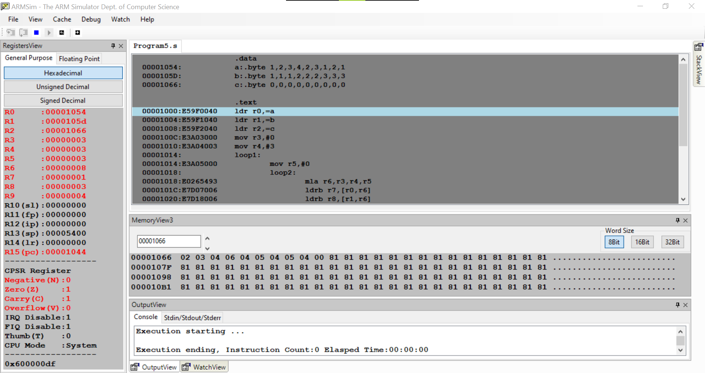

Week#____4_______ Program Number: ___6___

Consider a 2D array. Write an ALP using ARM7TDMI-ISA, to find the sum of all the elements in the array.

**Ex: Sum[i]=Sum[i]+a[i][j]**

**Code:**

.data

a:.byte 1,2,3,4,2,3,1,2,1

b:.byte 0

.text

ldr r0,=a

ldr r1,=b

mov r2,#0

mov r3,#3

loop1:

mov r4,#0

loop2:

mla r5,r2,r3,r4

ldrb r6,[r0,r5]

add r7,r6,r7

cmp r4,#2

add r4,r4,#1

bne loop2

cmp r2,#2

add r2,r2,#1

bne loop1

strb r7,[r1]

swi 0x11

